Difficulties in Use Case:
Use Case: Use Case is to analyse the document, first convert the pdf to text the feed the chunks on LLM so that we can get the desired json output then postprocess the output and the final output is excel UCT file.
1.Lots of formats of documents.
A. Qantas:
1. The documents contain numerous tables, which makes accurate extraction challenging. At times, the output is generated from tables that are not actually useful but closely resemble the tables that contain relevant information. This similarity can lead to confusion and incorrect data being extracted, making it more difficult to obtain the desired results from the documents.
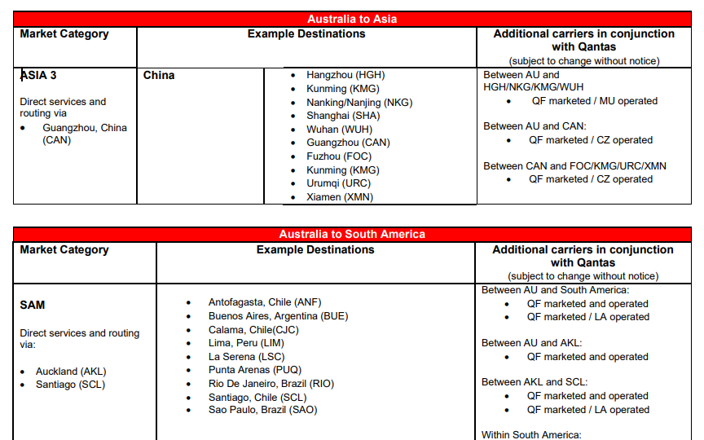
2. Some of the tables within the documents are empty, containing no meaningful data or values. When these empty tables are converted into text, it becomes challenging for the AI to interpret or generate accurate results, as there is a lack of information to analyze or process. This absence of data in the extracted text can negatively impact the quality and relevance of the AI-generated output.
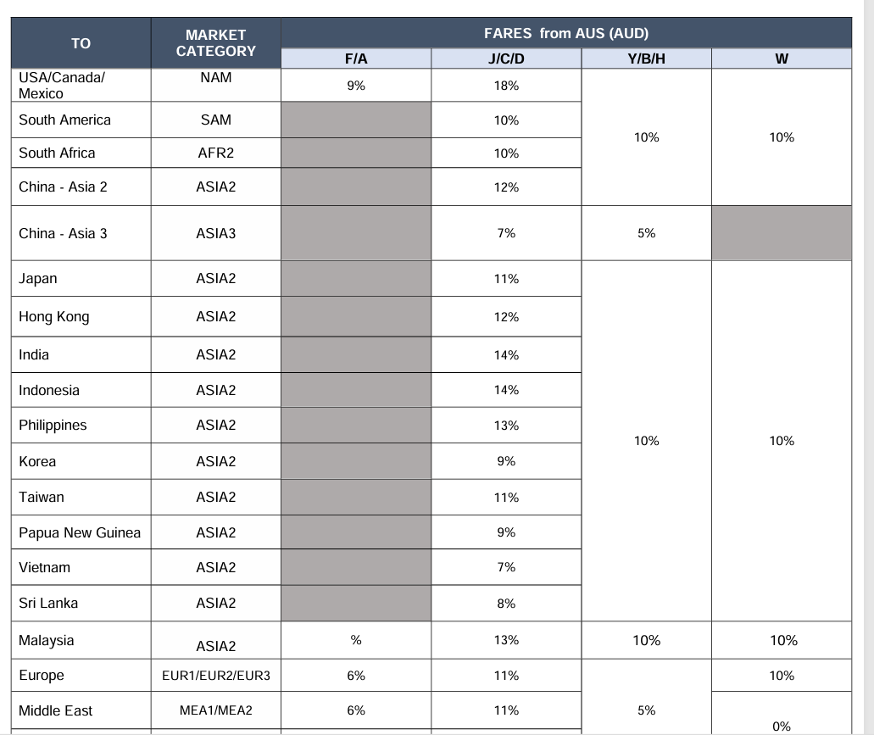

AA (AJB Disney): Some entities here also have blank or missing values.
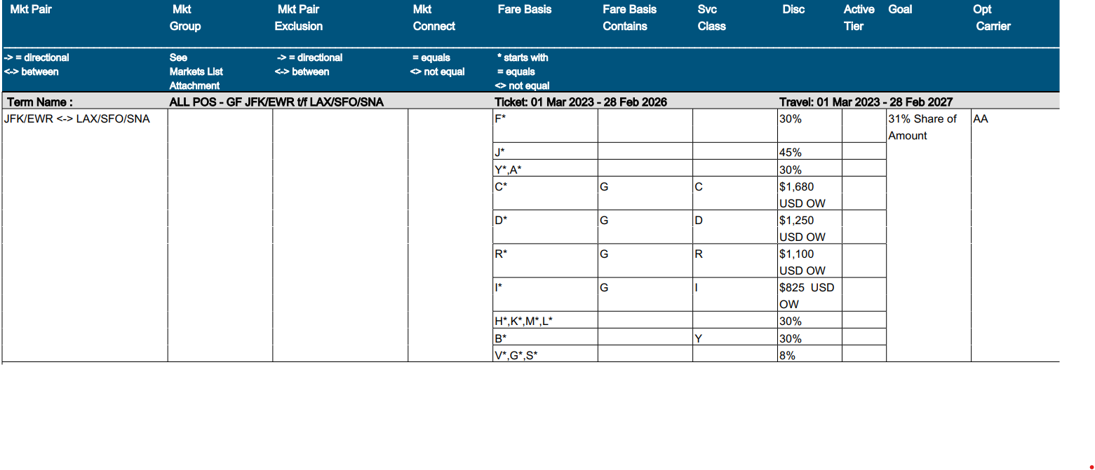
B. Invesco: Information is written as plain text with no clear structure, making it harder to find what we need.
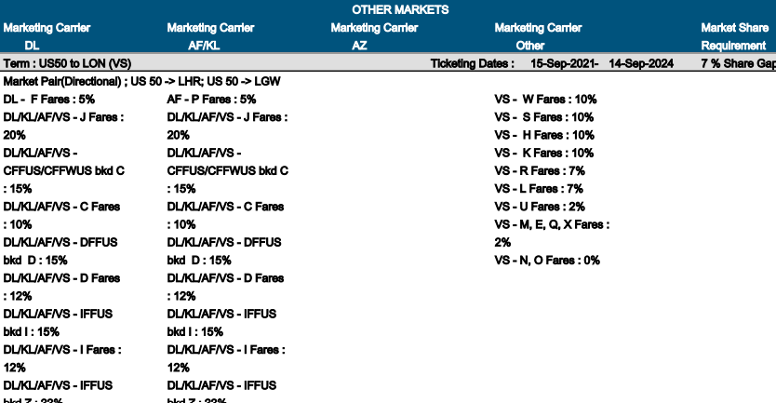

C. United JV format2
1. The document contains tables in multiple formats, which creates challenges for processing and extraction. Handling these varied formats requires more dynamic and flexible prompts to accurately interpret the data from each type of table.
Format 1:
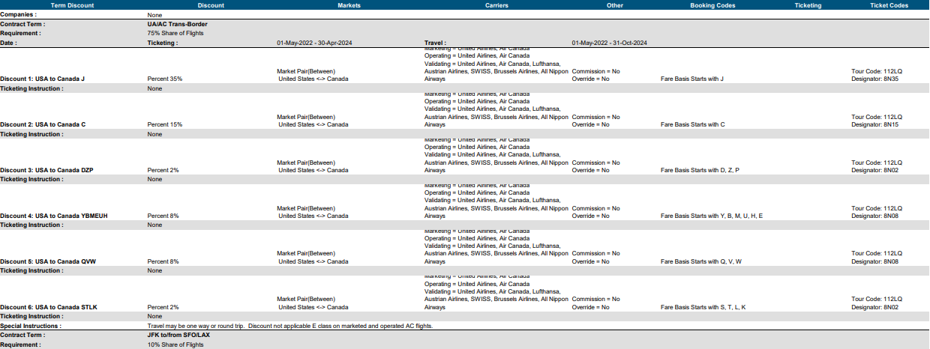
Format 2:
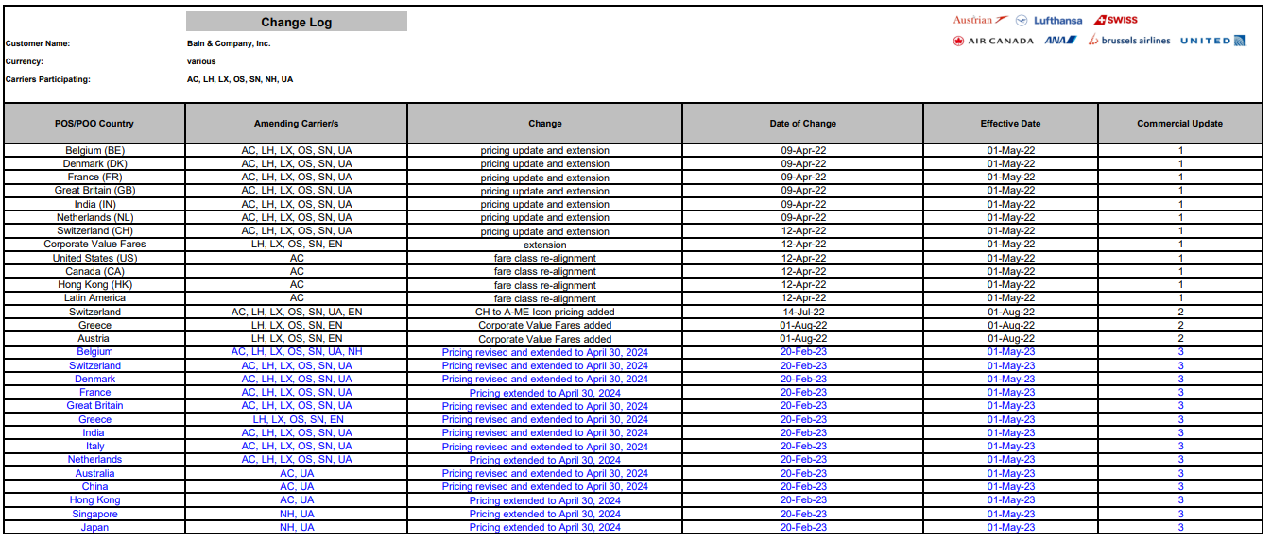
Format 3:
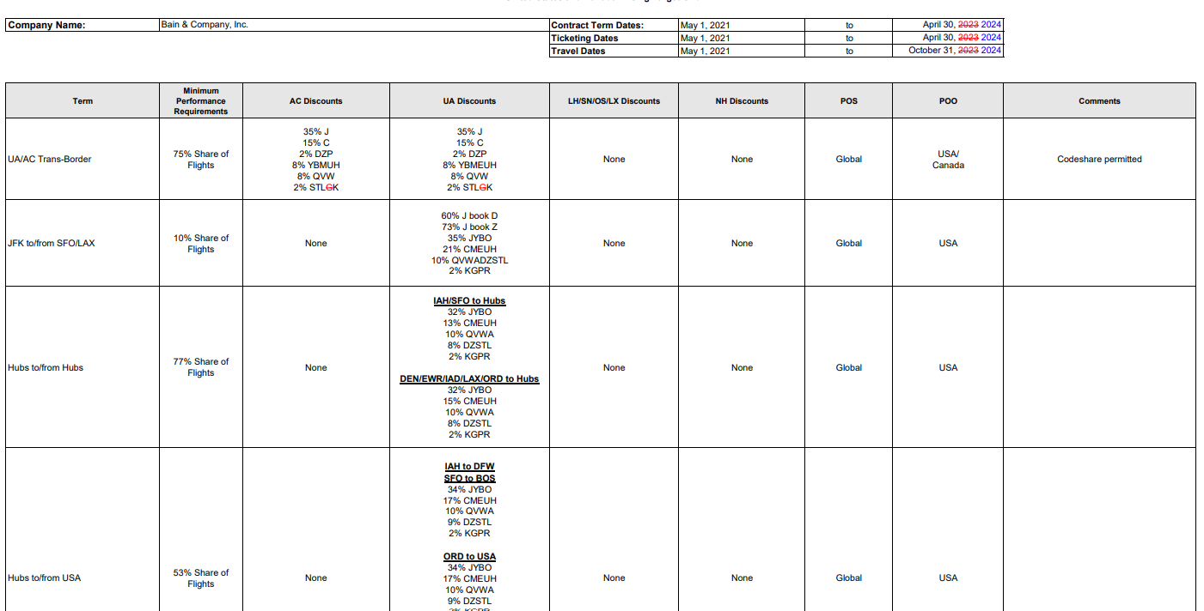

2. Some entries are marked in red, making it difficult to extract those data accurately.
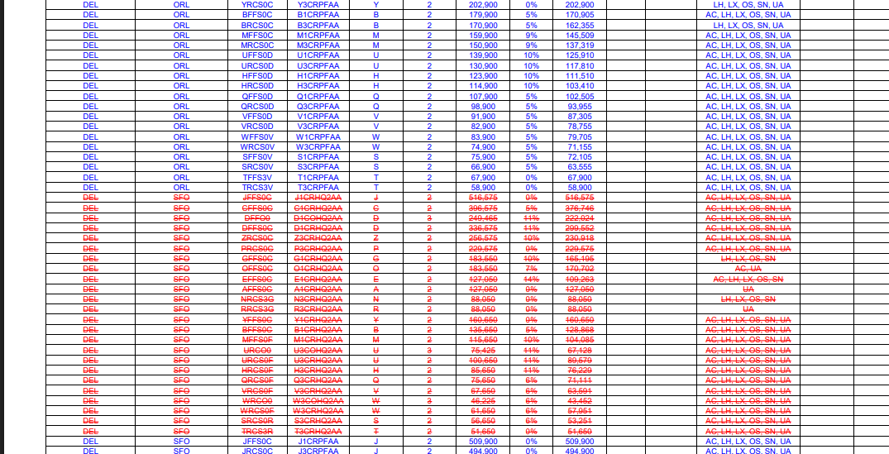
D. Disney: This document is very long (about 330 pages), so they take much longer to process.

2. Market
1. AA Markets: Some markets have mismatched starting and ending locations. Fixing these is tricky and needs careful checking.
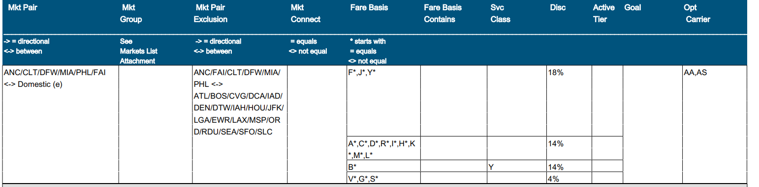
2. There exists a reference file that contains numerous locations, including cities and airports, which need to be updated or changed to their corresponding origin and destination depending on the airline. However, identifying the correct matches and making these changes can be quite challenging due to the complexity and the variety of possible combinations involved.

- PDF To Text:
  - Use case: When we are converting pdf to text format and send to LLM as user prompt and get the Json response.
    - Complexity
      - Lots of format
        - We have multiple formats for each airline. So we cannot fixed table header

- Aws Textract
- Camelot (Python library)

